**ABOUT – RELIANCE**

**Reliance Industries Limited (RIL)** is an Indian conglomerate holding company headquartered in Mumbai, Maharashtra, India. Reliance owns businesses across India engaged in energy, petrochemicals, textiles, natural resources, retail and telecommunications. Reliance is the second most profitable company in India, the second-largest publicly traded company in India by market capitalizationand the second largest company in India as measured by revenue after the government-controlled Indian Oil Corporation. The company is ranked 114th on the [Fortune Global 500](https://en.wikipedia.org/wiki/Fortune_Global_500) list of the world's biggest corporations, as of 2014. RIL contributes approximately 20% of India's total exports. It is ranked 14th among the Top 250 Global Energy Companies by [Platts](https://en.wikipedia.org/wiki/Platts).

The company was co-founded by Dhirubhai Ambani and his brother Champaklal Damani in 1960s as Reliance Commercial Corporation. In 1965, the partnership ended and Dhirubhai continued the [polyester](https://en.wikipedia.org/wiki/Polyester) business of the firm. In 1966, Reliance Textiles Industries Pvt Ltd was incorporated in Maharashtra. It established a [synthetic fabrics](https://en.wikipedia.org/wiki/Synthetic_fiber) mill in the same year at [Naroda](https://en.wikipedia.org/wiki/Naroda) in [Gujarat](https://en.wikipedia.org/wiki/Gujarat). In 1975, the company expanded its business into textiles, with "Vimal" becoming its major brand in later years.

In 1985, the name of the company was changed from Reliance Textiles Industries Ltd. to Reliance Industries Ltd. During the years 1985 to 1992, the company expanded its installed capacity for producing [polyester](https://en.wikipedia.org/wiki/Polyester) [yarn](https://en.wikipedia.org/wiki/Yarn) by over 145,000 tonnes per annum.

The Hazira petrochemical plant was commissioned in 1991–92.

In 1996, it became the first private sector company in India to be rated by international credit rating agencies

The years 1998–2000 saw the construction of the [integrated petrochemical complex at Jamnagar](https://en.wikipedia.org/wiki/Jamnagar_Refinery) in [Gujarat](https://en.wikipedia.org/wiki/Gujarat), the largest refinery in the world.

In 2002–03, RIL purchased a majority stake in Indian Petrochemicals Corporation Ltd. (IPCL), India's second largest petrochemicals company, from Government of India. IPCL was later merged with RIL in 2008. In the years 2005 and 2006, the company reorganized its business by demerging its investments in power generation and distribution, financial services and telecommunication services into four separate entities. In 2006, Reliance entered the organized retail market in India with the launch of its retail store format under the brand name of 'Reliance Fresh'.

**Major subsidiaries and associates**

* [Reliance Retail](https://en.wikipedia.org/wiki/Reliance_Retail)
* Reliance Life Sciences
* [Reliance Institute of Life Sciences](https://en.wikipedia.org/wiki/Reliance_Institute_of_Life_Sciences) (RILS)
* Reliance Logistics
* Reliance Clinical Research Services (RCRS)
* Reliance Solar
* [Relicord](https://en.wikipedia.org/wiki/Relicord)
* [Reliance Jio Infocomm Limited (RJIL)](https://en.wikipedia.org/wiki/Reliance_Jio_Infocomm_Limited_(RJIL))
* [Reliance Industrial Infrastructure Limited](https://en.wikipedia.org/wiki/Reliance_Industrial_Infrastructure) (RIIL)
* [LYF](https://en.wikipedia.org/wiki/LYF), a 4G-enabled VoLTE smartphone maker based in Mumbai

**Reliance Industries Limited – Dahej Manufacturing Division**

Dahej Manufacturing Division (DMD), an integrated petrochemical complex located near Jageshwar Village, Bharuch District, Gujarat, 130 Kilometers southwest of Vadodara which earlier known as Indian Petrochemical Corporation Limited (IPCL) Dahej Manufacturing Division located near Bharuch, Gujarat, is spread over 1,778 acres. It comprises of an ethane / propane recovery unit, a gas cracker, a caustic chlorine plant and 4 downstream plants, which manufacture polymers and fibre intermediates.

The Dahej Manufacturing Division consists of the following existing plants & related utilities which are in operation.

* Vinyl Chloride Monomer (VCM)
* Poly Vinyl Chloride Unit (PVC)
* Chlor-Alkali Unit (CA)
* Gas Cracker Unit (GCU)
* Ethylene Oxide/ Ethylene Glycol Unit (EO/ EG)
* High Density Poly Ethylene Unit (HDPE)
* Ethylene Vinyl Acetate (EVA)
* Ethane Propane Recovery Unit (EPRU)
* Purified Terephthalic Acid Unit (PTA)
* Polyethylene Terephthalate (PET)
* Utilities including Captive Power Plant

The complex has its own facility for separating ethane/propane from rich gas containing recoverable amounts of ethane / propane purchased from GAIL. The lean gas from which the ethane / propane has been extracted is returned to GAIL. The ethane / propane mixture is then used as a feedstock for the gas cracker plant.

The complex was commissioned in two phases in order to rationalize cash flows and level of borrowings. The Caustic Chlorine, VCM and PVC pants in phase one was commissioned in 1997. After this, in phase two, HDPE plant, MEG plant, ethane / propane recovery plant and gas cracker unit were commissioned in 2000.

RIL-DMD produces main products namely Polyvinyl Chloride (PVC), High Density Poly Ethylene,(HDPE), Mono Ethylene Glycol (MEG), Caustic soda lye & Ethylene Vinyl Acetate (EVA),Polyethylene Terephthalate (PET) & Purified Terephthalic Acid (PTA) along with some valuable chemical by products like HCl, Wax, DEG, TEG, Mix Oil, RARFS etc., which are either consumed internally, exported to sister divisions or sold in the open market. Propylene produced in Gas Cracker Plant of DMD, which is a raw material for manufacture of PP Polymer, is exported to VMD where it has PP manufacturing Plant through connected piping network.

**PURIFIED TEREPTHALIC ACID PLANT**

1. **INTRODUCTION**

PTA has the form of a white, crystalline powder and looks like powdered sugar. It is quite inert, which means that, for example, it is difficult to dissolve in water or other liquids. PTA is an aromatic acid, primarily applied in the production of polyester. The main raw material for PTA is paraxylene (PX).

When Amoco Chemicals Belgium was established in 1967, the production of PTA (purified terephthalic acid) had already been planned. In 1969, the first PTA unit (PTA1) came on line and in 1991 the second one (PTA2) followed.

1. **RAW MATERIALS AND CHEMICALS**

* Paraxylene (raw material)
* Compressed air (raw material)
* Hydrobromic acid (promoter)
* Cobalt acetate (catalyst)
* Manganese acetate (catalyst)
* CMA catalyst solution
* Acetic acid (solvent)
* Normal propyl acetate (entrainer)
* Oxalic acid (catalyst recovery reagent)
* Sodium formate
* Platinum
* Hydrogen (for purification)
* Caustic soda 5% w/w (off gas scrubbing)

1. **PROCESS CHEMISTRY**
   1. **Oxidation chemistry**

Terephthalic acid (TA) is produced by the liquid-phase air oxidation of paraxylene in acetic acid solvent, and is catalyzed by soluble cobalt, manganese and bromine compounds

The water produced as a by-product of the reaction will slow down or inhibit the rate of reaction if allowed to build up in the liquid phase and is therefore continually withdrawn from the reactor. The overall reaction is extremely quick and typical reactor product only contains 0.2 to 0.3% of 4-carboxybenzaldehyde (4CBA), the major impurity.

*The reaction is highly exothermic, liberating close to 3,000 kcals or 12,500 kJ per kg of paraxylene consumed.* The reaction proceeds via a series of steps in which each methyl group is sequentially oxidized via the aldehyde to the acid



The slowest step in the above series of reactions is the oxidation of paratoluic acid; hence this acid is the intermediate present in the largest quantity. Since paratoluic acid is soluble in acetic acid solvent it does not appear as the major impurity in the CTA product. 4CBA, although present in smaller amounts in the reactor is much less soluble in acetic acid: It co-precipitates with terephthalic acid and hence appears as the major impurity in CTA.

The process achieves a high yield of terephthalic acid from paraxylene - typically 96-97% of stoichiometry

Apart from some unreacted paraxylene escaping in the vapour stream leaving the reactor, there are other reactions forming by-products such as benzoic and trimellitic acids and some burning to CO/CO2. Impurities in the paraxylene feed, such as ortho and metaxylenes, toluene and ethylbenzene are respectively oxidised to ortho and isophthalic acids and benzoic acid.

Although Acetic acid does not appear in the main reaction sequence, acetic acid has an important role in the oxidation process. It serves as a solvent for both paraxylene and the cobalt/manganese/bromine catalyst in the reactor feed and it forms slurry with the precipitated CTA crystals, enabling the product to be easily removed from the reaction system. Acetic acid losses are a major economic consideration in the operation of the process hence, the process conditions must be optimised to give the desired level of 4CBA in the product whilst minimising acetic losses. The overall reaction is as follows:



**3.2** **Purification Chemistry**

The function of the Purification Plant is to reduce the levels of intermediates and by-products. This is achieved by dissolving the CTA in water at high pressure / temperature and reacting the impurities with Hydrogen in the presence of a catalyst. This is called a Hydrogenation reaction. This reaction effectively converts the impurities into more soluble or non-coloured forms, which stay dissolved in the water phase in the subsequent crystallisation stage. Both CTA and 4CBA are very insoluble but p-TA is soluble. The p-TA and other non-coloured forms are purged from the plant in the mother liquor from the primary solid/liquid separation stage.

The main reactions that take place are: -

a) 4-CBA + Hydrogen p-TA + water (or to 4-carboxy benzyl alcohol).

Both products are soluble in water.

b) Colored impurities + Hydrogen Non -colored impurities or to soluble colored impurities.



PTA – 5 & PTA – 6 (DMD) (ACCORDING TO YOUR MENTOR)

The PTA PLANT is designed for an annual capacity of 1,120,000 tonnes of Pure Terephthalic acid (PTA).

The PTA PLANT is designed to produce this output in an 8000 hour operating year, based on a flow sheet rate of 140 te/h of PTA, on a single stream basis. This rate is referred to as the normal capacity.

Design flexibility of the PTA PLANT is expected to allow operation in the range 70 – 110% of normal capacity.

**Raw Materials required for 100 % normal capacity**:

|  |  |
| --- | --- |
| Raw Materials | Specific Consumption  (Kg/TON of PTA) |
| Paraxylene | **656** |
| Acetic acid (as 100%) | **35.5** |
| Cobalt (as metal) | **0.03** |
| Manganese (as metal) | **0.06** |
| HBr (as 100%) | **0.55** |
| Entrainer (Normal Propyl Acetate) | **0.70** |
| Catalyst Recovery Reagent (Oxaylic Acid) | **0.5** |
| Support Fuel (Methanol) | **2.62** |
| Caustic (100%) | **4.96** |
| Sodium Formate (as 100%) | **0.04** |
| Hydrogen (as 100%) | **0.12** |

**Utility Consumption for 100% capacity:**

|  |  |
| --- | --- |
| **Item Description** | **Normal (per TON of PTA)** |
| Power | **25.56 KWh** |
| Superheated HP Steam | **0.69 Ton** |
| Demineralised Water | **1.87 m3** |
| Cooling water Circulation Flow | **330 m3** |
| Industrial Water | **0.25 m3** |
| Nitrogen | **1.5 Nm3** |

**OXIDATION SECTION:**

1. **GENERAL PROCESS:**

The Oxidation Plant is designed for continuous operation and consists of six main sections: Process Air Compression and Offgas Treatment, Reaction, CTA Crystallisation, Separation & Drying, Catalyst Recovery and Solvent Recovery.

In the Process Air Compression and Offgas Treatment Section atmospheric air is compressed and fed to the reactor. Cooled offgas from the reactor is heated and passed over a catalyst before passing through an expander, being scrubbed and discharged to atmosphere.

In the Reaction Section paraxylene feedstock is mixed with acetic acid solvent and catalyst solution and reacted with air. The major proportion of the terephthalic acid produced in the exothermic reaction is precipitated in the reactor to form slurry.

In the CTA Crystallisation Section the reactor exit slurry is depressurised and cooled in a series of three crystallising vessels. The precipitated terephthalic acid product is recovered in the Separation and Drying Section by continuous filtration incorporating a solvent wash stage. A proportion of the mother liquor generated in this stage is purged to Catalyst Recovery. Residual solvent acetic acid in the filter cake is removed in a continuous drier. The resultant product is conveyed to intermediate storage on the Purification Plant.

In the Catalyst Recovery Section, catalyst is recovered from the Oxidation Plant mother liquor purge. The composition of recovered catalyst is adjusted to produce a catalyst solution for feed to the Reaction Section.

In the Solvent Recovery Section, impure solvent recovered from the Reaction, Catalyst Recovery and CTA Recovery Sections, is processed to remove acetic acid and water from the higher boiling reaction by-products. The recovered solvent is fractionated to remove low-boiling impurities and the water of reaction, and produces purified acetic acid suitable for re-use in the Plant. The higher-boiling by-products are quench cooled in water and the resulting slurry disposed of in a Thermal Oxidizer or cooled and solidified in a Residues Flaker for subsequent processing OSBL.

1. **EQUIPMENT DESCRIPTION**
   1. **OXIDATION REACTOR:**

The Oxidation Reactor is a vertical, agitated pressure vessel constructed from titanium-clad carbon steel. It has an internal diameter of 9920 mm and a tan-to-tan height of 9800 mm, providing a total volume of approximately 1013 m³. The vessel has an elliptical head and base and contains four equi-spaced baffles which extend from the bottom dished end to the top tangent line. The Reactor has a design pressure of 20.9 barg and a design temperature of 281°C. All vessel internals are **titanium**.

|  |  |  |  |  |  |  |
| --- | --- | --- | --- | --- | --- | --- |
| Design Conditions | | Operating Conditions | | Dimensions | | MOC |
| Pressure | Temperature | Pressure | Temperature | Diameter | Height |  |
|  |  |  |  |  |  |  |

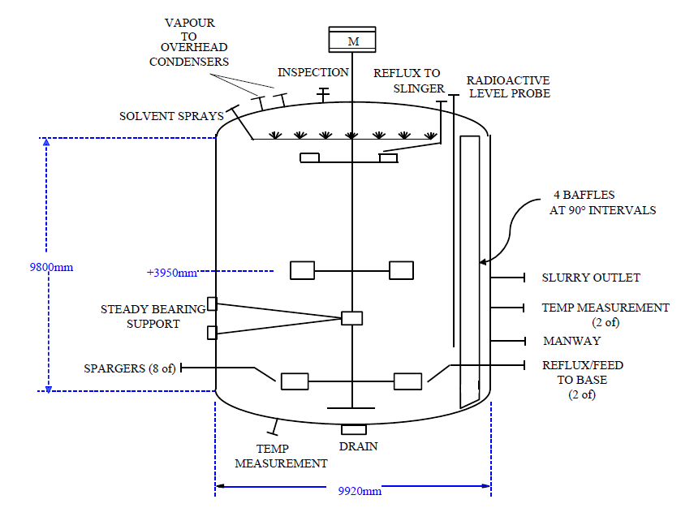

Air is supplied to the Reactor through eight sparger pipes. These are located at 45° intervals near the base of the Reactor with the internal pipe outlets at the same elevation as the centreline of the curved radial blade impeller.

Each air line is equipped with a velocity averaging Pitot tube (“annubar”) flowmeter, a flow control valve, and a tight shut-off block valve. The line changes specification from stainless steel to titanium immediately downstream of the block valve. One of the spargers is provided with a bypass around its associated main flow control valve for start-up purposes. The bypass is equipped with its own flowmeter and flow control valve.

The Reactor is fitted with internal sprays in the head space. This serves three purposes:-

a) Warming of vessel walls during start-up. Heated solvent or Mother Liquor is fed through the sprays from the Start-up Heater, E5-313.

b) Cooling down of the vessel walls during shutdown. Solvent or Mother Liquor can be fed to the sprays via the Start-up Heater and the temperature of the solvent/Mother Liquor is reduced in a controlled manner.

c) Cleaning of vessel walls during washout. Caustic solution (5% NaOH, 80°C) can be used to wash down the vessel and neutralise any remaining acetic acid vapour prior to vessel entry.

During normal operation a nominal flow of HP solvent is put through these sprays to prevent build-up of solids in the spray nozzles.

A manway is provided for vessel inspection and this is located close to the vessel bottom tan line.

Reactor Level Control:

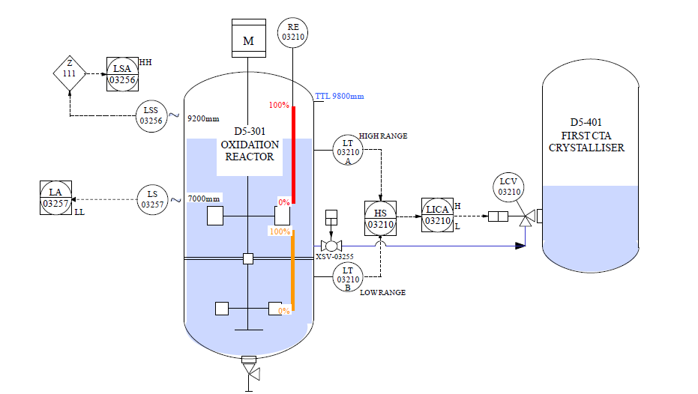

Level is measured using radioactivity. A set of radiation sources, RE-03210 is housed in an internal dip tube, which is sealed from the process. This radiation source can be lowered and raised within the dip tube and when in the lowered position, radiation is directed through the Reactor wall to detectors. Two fixed point detectors are located approx. 9200 mm and 7000 mm respectively from the vessel bottom tan line. Two tubular detectors cover two separate ranges at the top and bottom of the vessel rather than one continuous range over the whole height.

The normal operating level for the Reactor, with aerated slurry and with the agitator running is 8000 mm above the bottom tan line. This lies within the upper range of detection. The low measurement range is only utilised during abnormal operation such as start-up, shut-down and Reactor hold, when the Reactor contents are unaerated. In these circumstances the level falls to approx. 47% of the normal height which is outside the range of the upper detector.

The signal from LT-03210A or B is selected by HS-03210 and passes to LICA-03210 which is used to control the Reactor level by adjusting the slurry flow from the Reactor into the First CTA Crystalliser. The level control valve LCV-03210 is mounted on the First CTA Crystalliser vessel in order to minimise the distance between the valve and vessel. LICA-03210 has high and low alarms in the DCS set at 9000 mm and 7200 mm respectively above the bottom tan line. Note that these apply only to the top range of operation.

LSS-03256 provides the signal for the high level trip, LSA-03256, whilst LS-03257 provides the signal for extra low level alarm, LA-03257. These are set at 9200 mm and 7000 mm respectively above the bottom tan line.

* 1. **Crystallizers**

The purpose of the Crystallisation Stage is to reduce the pressure and temperature of the Reactor products so that the TA crystals can be separated from the Mother Liquor by the Rotary Vacuum filters. The Crystallisers also provide buffer capacity between the Reaction and Product Recovery Sections.

The Product from the Reactor is let down in pressure under level control into the First CTA Crystalliser D5-401. Acetic Acid and water are flashed off and the vapour condensed by cooling in the First CTA Crystalliser Condenser E5-430. Further cooling of the vapour takes place in the First CTA Crystalliser Vent Condenser, E5-431, before being discharged into the HP Absorber D5-310.

The **First CTA Crystalliser** is a titanium clad carbon steel vessel fitted with bleed tubes

or "Tell Tales" through the carbon shell to areas where the titanium sections are

welded. If the welds fail then the bleed holes will pass liquid and warn of the leak

before any serious damage to the carbon steel begins. The bleed holes must be kept

clear of any vessel lagging and should be inspected daily.

The vessel is sized to provide adequate residence time for product quality control and to

provide “buffer” capacity during plant upsets. Vessel diameter is designed to ensure

minimal solids carryover in the vapour stream from the vessel. The maximum design

pressure and temperature of the Crystalliser are 19.7 barg and 281 degC and it is also

designed to withstand full vacuum.

The Crystalliser has diameter of 5800 mm and height of 8500 mm between upper and

lower tangent lines. The vessel has an elliptical head and base and contains 4 equally

spaced baffles, which extend from the bottom dished end to height 8075mm from the

bottom tangent line. Vessel total capacity is 276 m3 with a normal operating volume of

168 m3, or approx. 55% of the level measurement range. All vessel internals are

Titanium.

The offgas from the First CTA Crystalliser is analysed continuously for oxygen and carbon dioxide downstream of the First CTA Crystalliser Vent Condenser. Three sampling conditioning systems are provided to further cool the gas and remove any volatiles to prevent contamination and flooding in the analysers.

The **Second CTA Crystalliser** is a titanium clad carbon steel vessel fitted with bleed tubes or „Tell Tales‟ through the carbon shell to areas where the titanium sections are welded. If the welds fail then the bleed holes will pass liquid and warn of the leak before any serious damage to the carbon steel begins. The bleed holes must be kept clear of any vessel lagging and should be inspected daily.

The slurry feed from the First CTA Crystalliser enters the Second CTA Crystalliser through the First CTA Crystalliser level control valve, which is pad mounted on the side of the Second Crystalliser. Slurry leaves the vessel and is fed to the Third CTA Crystalliser through a nozzle, located on the vessel side. Both the feed line and discharge line are provided with solvent flush, caustic flush and drain facilities.

The **Third CTA Crystalliser** is constructed from duplex stainless steel and is sized to provide “buffer” capacity during plant upsets. The maximum design pressure and temperature of the Crystalliser are 4.1 barg and 170 degC. It is also designed to withstand full vacuum.

The slurry feed from the Second CTA Crystalliser enters the Third CTA Crystalliser through the Second CTA Crystalliser level control valve which is pad mounted on the side of the Third Crystalliser. Slurry leaves the vessel and is fed to the Third CTA Crystalliser Transfer Pumps, G5-407A/B through two pad mounted angle valves located on the vessel base dished end. Both the feed line and discharge/pump suction lines are provided with solvent flush, caustic flush and drain facilities.

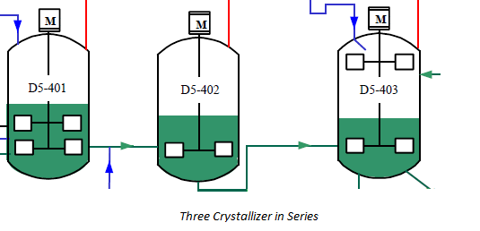

**For Crystallizer 1 :**

|  |  |  |  |  |  |  |
| --- | --- | --- | --- | --- | --- | --- |
| Design Conditions | | Operating Conditions | | Dimensions | | MOC |
| Pressure | Temperature | Pressure | Temperature | Diameter | Height |  |
|  |  |  |  |  |  |  |

For Crystallizer 2 :

|  |  |  |  |  |  |  |
| --- | --- | --- | --- | --- | --- | --- |
| Design Conditions | | Operating Conditions | | Dimensions | | MOC |
| Pressure | Temperature | Pressure | Temperature | Diameter | Height |  |
|  |  |  |  |  |  |  |

For Crystallizer 3:

|  |  |  |  |  |  |  |
| --- | --- | --- | --- | --- | --- | --- |
| Design Conditions | | Operating Conditions | | Dimensions | | MOC |
| Pressure | Temperature | Pressure | Temperature | Diameter | Height |  |
|  |  |  |  |  |  |  |